Probots Robot Design Executive Summary

Robot Facts:

Our plan was to finish the easy missions that didn’t need much programming and a complex design.   To build it faster, we used rectangular design instead of a box design. We used three motors, two large motors and one medium motor. We used one sensor, the color sensor. We have seven programs.

Design Details:

**Fun:** We had a lot of fun doing robotics. We had fun synergizing and working together. Most importantly no one was left out. We cooperated to do the EV3 missions and the dissection project. We split into 2 groups and each person in each group had a job , so no one was left out. A part that we all liked is that we were with each other.

**Strategy**: Our strategy was to go for the main missions like Shark Shipment, Service Dog, Milking Automation, and Feeding that gave us a lot of points, rather than going for ‘extra’ missions that don't give much points. As the missions became more difficult, we modified our robot, which made it more complex.

**Design Process**: Our design process included multiple robots for examples, we had two robots when we split into two teams and made two robots. We often discussed what was going wrong with the robot. For example: when we were using the color Devesh pointed out it was tilting, so we decided come up with a new design, that used Soham’s idea. Another example was the initial claw was slipping of the refrigerator axles and the pulley system kept losing its rubber band. We decided to go with Zinnun’s design on it.

**Innovation:** We think that our feeding attachment is special because we used a pulley system. That pulley system worked out really well. We made claws that went back and forth to get the food out of the refrigerator. We even had a space to keep the food and get it back to base. That same attachment was used to get the food to the gorilla, the flamingo, and the bat.

**Mechanical Design :** Please see Picture on Page 2

**Programming** : Please see Screenshot of Program on Page 3

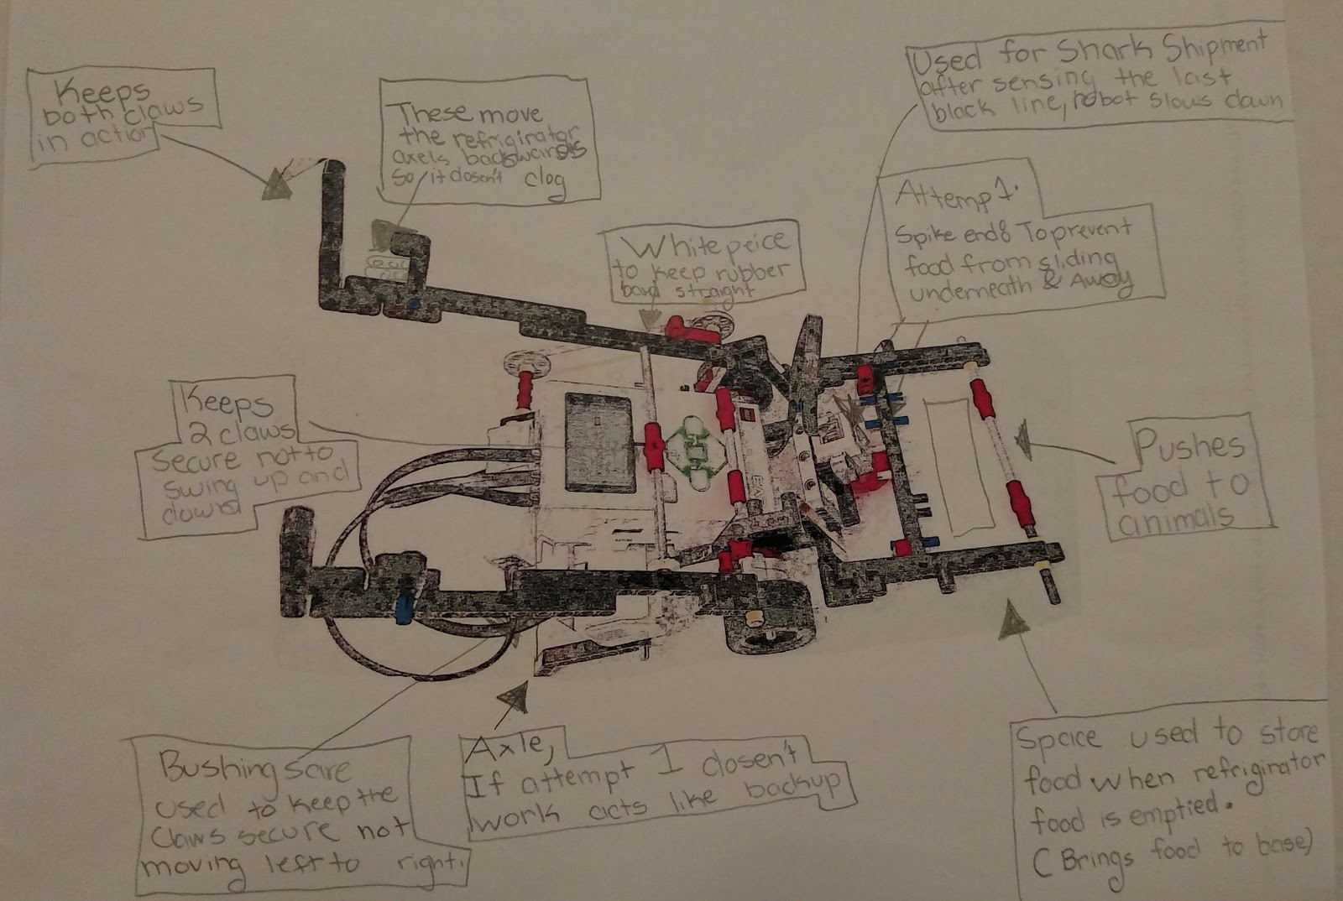

**Page 2**

**Our Mechanical Design**

**Page 3**